Nathan Sirere

**Cybersecurity** (Online) 2:00PM-4:00PM

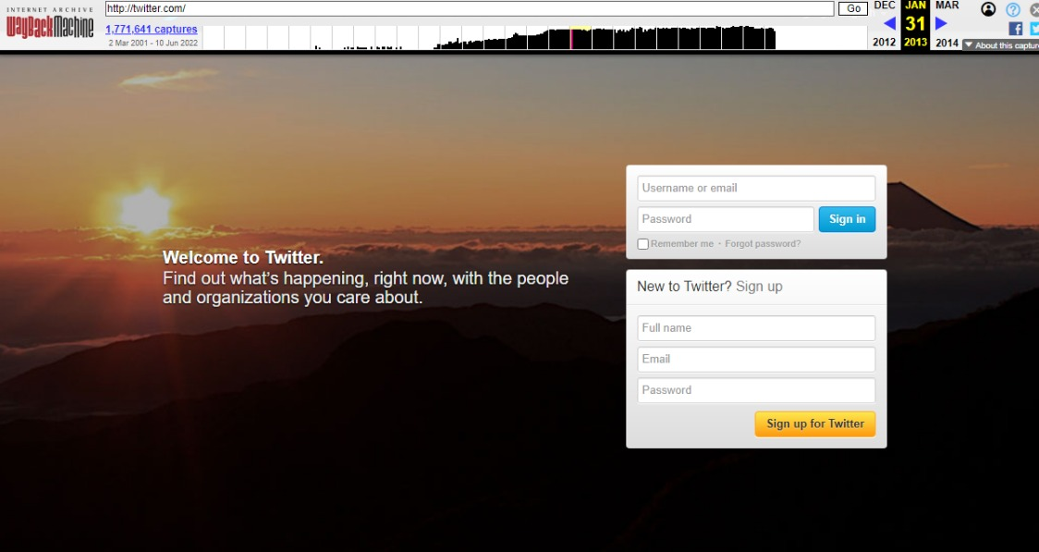

Twitter website on 31st January 2013

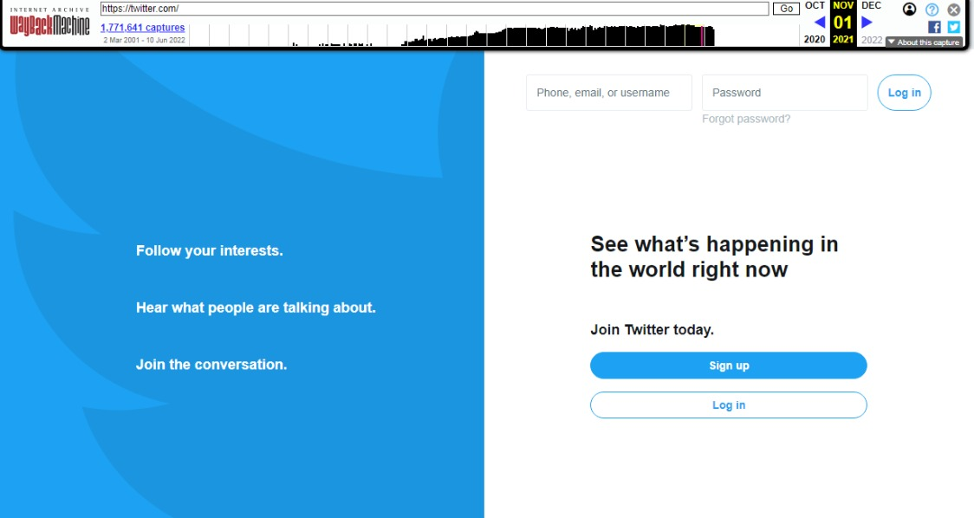

Twitter website on 01st November 2021



Facebook.com on 18th May 2004

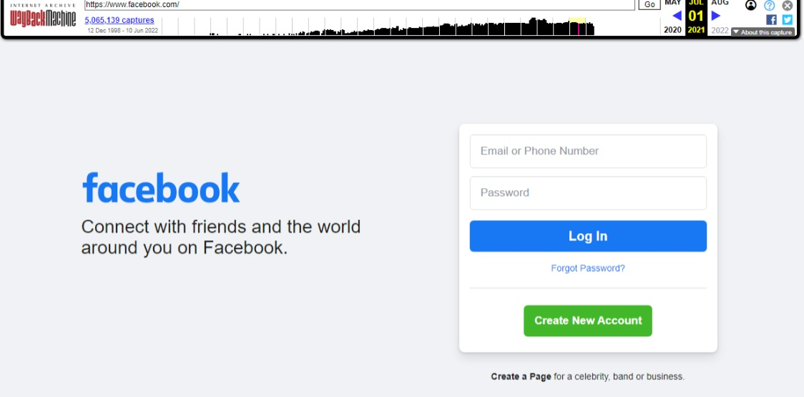

Facebbok.com on 01th June 2021